Other Raymond Loewy Designs
Raymond Loewy was one of the world’s leading industrial designers.

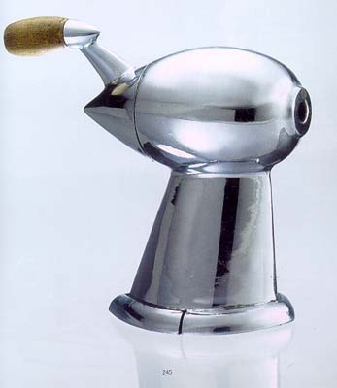
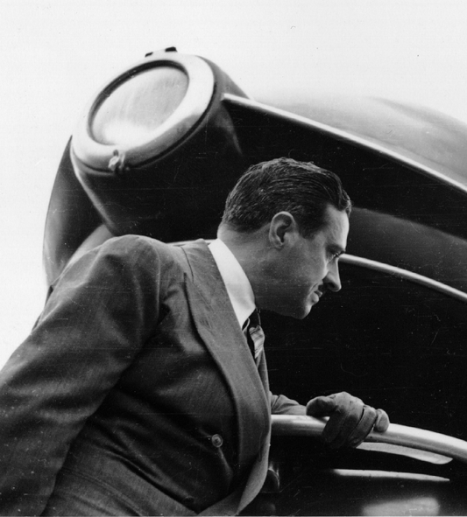
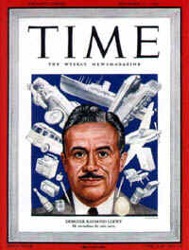

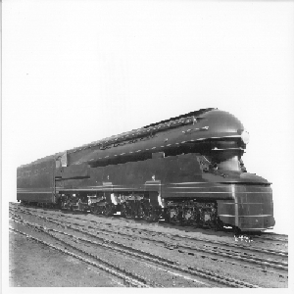

Pencil Sharpener

1933
Raymond Loewy 1893 – 1986

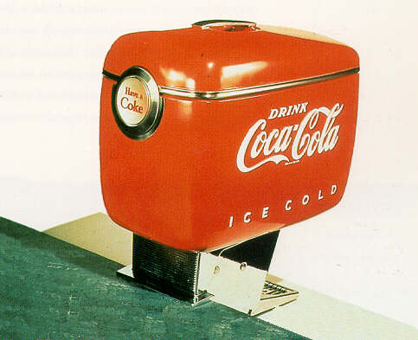
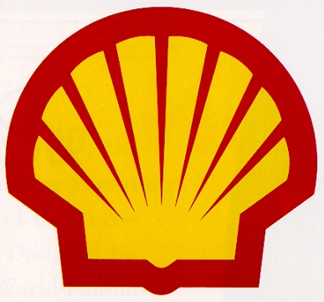

Coca Cola Dispenser

1947

Shell Oil Logo

1967

Pennsylvania S1 Locomotive

1937

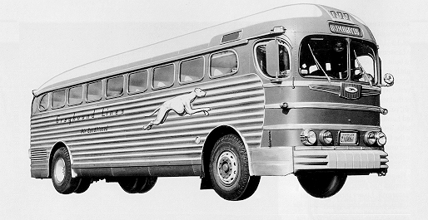
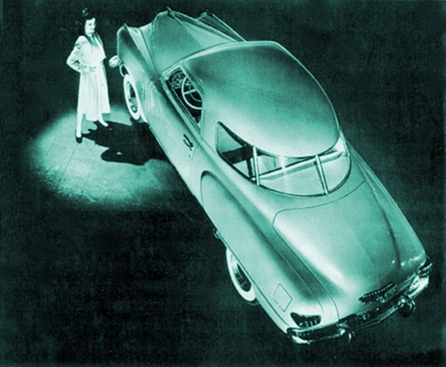
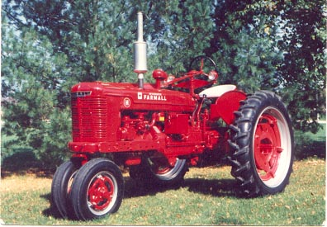

Greyhound Bus

1940

Studebaker Champion

1947

Farmall H Tractor

1940

Still more Raymond Loewy Designs…

U.S. Post Office logo Gestetner duplicating machine
Coldspot Refrigerators Nabisco Logo
Hallicrafters Radios 1932 Hupmobile
Pepsodent Packaging Singer Vacuum Cleaners
Rosenthal China Exxon Logo
Interior of NASA’s Skylab IBM Selectric Typewriter

Interior of the Concorde “Air Force One” Interior and Paint Scheme

